# Fake News Detection System

Submitted in partial fulfillment of the requirements of the degree of

BACHELOR OF ENGINEERING

in

Information Technology

by

Hiten Bahrani

Abhishek Darak

Jatin Khushalani

Supervisor

Prof. Sunita Rathod

( Department of Information Technology, TSEC)

‘

‘ 

Department of Information Technology

Thadomal Shahani Engineering College

University of Mumbai

2023-2024

# CERTIFICATE

This is to certify that the project entitled **“Fake news Detection System”** is a bonafide work of (2005003) Hiten Bahrani, (2005013) Abhishek Darak, (2005048) Jatin Khushalani Submitted to the University of Mumbai in partial fulfillment of the requirement for the award of the degree of

**“BACHELOR OF ENGINEERING”** in **“INFORMATION TECHNOLOGY”**.

Prof. Sunita Rathod

(Project Guide)

Dr. Mukesh Israni Dr. G. T. Thampi

(Head of Department) (Principal)

# Major Project Report Approval for B.E

Project report entitled Fake News Detection System by (2005003) Hiten Bahrani, (2005013) Abhishek Darak, (2005048) Jatin Khushalani is approved for the degree of **“BACHELOR OF**

**ENGINEERING”** in **“INFORMATION TECHNOLOGY”**

Examiners

1.**_________________________**

2.**_________________________**

Date: 04-05-2024

Place:

## Declaration

I declare that this written submission represents our ideas in our own words and where others' ideas or words have been included, we have adequately cited and referenced the original sources. We also declare that we have adhered to all principles of academic honesty and integrity and have not misrepresented or fabricated or falsified any idea/ data/ fact/ source in our submission. We understand that any violation of the above will be cause for disciplinary action by the Institute and can also evoke penal action from the sources which have thus not been properly cited or from whom proper permission has not been taken when needed.

1. Hiten Bahrani
2. Abhishek Darak
3. Jatin Khushalani

Date: 04-05-2024

## Abstract

The proliferation of fake news has emerged as a critical challenge in the era of information abundance, impacting public discourse, trust in media, and even democratic processes. This study presents a comprehensive approach to address this issue through the development of a machine learning-based fake news detection system. Leveraging a diverse dataset comprising both genuine and fabricated news articles, we employ natural language processing techniques to extract relevant features. These features encompass linguistic patterns, semantic structures, and contextual information, allowing for a nuanced analysis of the text.

Our system incorporates a multi-faceted feature extraction pipeline, encompassing lexical, syntactic, and semantic elements. Additionally, we integrate external contextual cues, such as social media engagement metrics and source credibility scores, to enhance the model's discriminatory power. Through a thorough evaluation process on a benchmark dataset, our system demonstrates robust performance in distinguishing fake news from genuine content.

To mitigate potential biases and enhance generalizability, we adopt transfer learning techniques, leveraging pre-trained language models on a vast corpus of text. This enables our system to adapt to evolving linguistic nuances and maintain effectiveness across diverse news domains.

### Table Of Content

**Sr.No Topic Page**

1. **Introduction** 1
   1. Introduction 1
   2. Aims and Objectives 1
   3. Scope 2
2. **Review of Literature** 3
   1. Domain Explaination 3
   2. Review of Exisiting System 5
   3. Limitaions of Existing System/ Research Gaps 5
3. **Proposed System** 6
   1. Analysis/ Framework 6
   2. Design Details 6
   3. Methodology 6
4. **Implementation Details** 11
   1. Experimental Setup 11

4.1.1 Dataset Description/ Database details 12

* 1. Perfomance Evaluaion 13
  2. 4.3 Software and Hardware setup 14

1. **Conclusion** 15

**6**  **References** 16

**1. Introduction**

#### 1.1 Introduction

In recent years, the rise of fake news has emerged as a pressing concern in the digital age. The proliferation of false or misleading information through online platforms has the potential to significantly impact public discourse, trust in media, and even influence societal decision-making processes. Fake news encompasses a wide range of deceptive content, including fabricated stories, manipulated images, and misleading headlines, often disseminated with the intent to misinform or deceive.

Addressing the challenge of fake news requires innovative approaches that leverage advanced technologies and data-driven methodologies. One such approach involves the development of Fake News Detection Systems, which utilize machine learning, natural language processing (NLP), and other computational techniques to analyze and classify news articles based on their veracity.

This research endeavors to introduce and elaborate on a sophisticated Fake News Detection System that employs a multifaceted approach to discern between genuine and fabricated news content. By harnessing the power of linguistic analysis, contextual cues, and machine learning algorithms, this system aims to provide users with a reliable tool to critically evaluate the information they encounter online.

The key components of our Fake News Detection System include feature extraction techniques that delve into the linguistic nuances of news articles, allowing for the identification of patterns commonly associated with fabricated content. Additionally, external contextual information, such as social media engagement metrics and source credibility scores, are integrated to augment the system's decision-making process.

Furthermore, the utilization of transfer learning techniques empowers our system to adapt to evolving linguistic trends and remain effective across a broad spectrum of news topics and genres. By leveraging pre-trained language models, the system gains the capacity to understand complex linguistic structures and contextual nuances, thereby enhancing its overall performance.

In this paper, we will provide a detailed exposition of the methodology employed in the development of our Fake News Detection System, including feature selection, model training, and evaluation metrics. Additionally, we will present the results of rigorous testing on benchmark datasets, demonstrating the system's efficacy in accurately discerning fake news from genuine content.

#### 1.2 Aim and objective

The aims and objectives of a Fake News Detection System are designed to address the growing challenge of misinformation in the digital age. Here are some key aims and objectives:

* To Identify and Distinguish Fake News: The primary aim is to develop a system that can accurately differentiate between genuine and fabricated news articles. This involves employing advanced computational techniques to analyze linguistic patterns, contextual cues, and other relevant features.
* Enhance Information Integrity: The system aims to contribute to the integrity of information ecosystems by providing users with a reliable tool to critically evaluate the content they encounter online. This helps in reducing the spread of false or misleading information.
* Empower Users: The system aims to empower users with the ability to make informed decisions about the credibility of news sources. By providing a tool that assists in discerning reliable information, users can navigate the online information landscape with greater confidence.
* Mitigate the Impact of Misinformation: By accurately detecting and flagging fake news, the system aims to reduce the potential harm caused by misinformation. This can help safeguard public discourse, trust in media, and even democratic processes that rely on accurate information.
* Utilize Advanced Computational Techniques: The objective is to leverage state-of-the-art technologies like machine learning, natural language processing (NLP), and transfer learning to create a robust and effective detection system. These techniques enable the system to adapt to evolving linguistic nuances and remain effective across various news domains.

* Minimize False Positives and Negatives: Striking a balance between minimizing false positives (identifying genuine news as fake) and false negatives (missing actual fake news) is a crucial objective. The system should be designed to achieve a high level of accuracy and reliability in its classifications.
* Incorporate Contextual Cues: The system aims to integrate external contextual information, such as social media engagement metrics, source credibility scores, and other relevant data, to enhance its decision-making process. This helps provide a more comprehensive assessment of the news articles.
* Provide Transparency and Explainability: Ensuring that the system's decisions are transparent and can be explained is an important objective. Users should have insights into why a particular news article is classified as fake or genuine, promoting trust and accountability.
* Scalability and Generalizability: The system should be designed to handle large volumes of data and be applicable across diverse news topics and genres. This ensures that it remains effective in different contexts and can adapt to emerging trends.
* Real-world Deployment and Impact Assessment: Finally, the system's effectiveness should be validated through real-world deployment in simulated or controlled environments. Its impact on users' ability to discern reliable information sources should be assessed to gauge its practical utility.

By aligning these aims and objectives, a Fake News Detection System endeavors to contribute to a more informed, discerning, and resilient information ecosystem in the digital age.

**1.3 Scope**

The project implemented by us in developing a static fake news detection system had several limitations that constrained its effectiveness and usability. Firstly, the system's static nature restricted its applicability to dynamic environments where news content is continuously updated. As a result, the system's capability to detect fake news was limited to the datasets available at the time of implementation, lacking the agility to adapt to real-time information streams.

Furthermore, the reliance on a machine learning model for classification introduced inherent constraints related to model performance and accuracy. The effectiveness of the fake news detection system heavily depended on the quality and representativeness of the training data used to train the ML model. Limited access to diverse and comprehensive datasets may have hindered the system's ability to accurately identify fake news across different contexts and domains.

Additionally, the static nature of the system implied a lack of real-time feedback mechanisms for continuous learning and improvement. Without the capability to dynamically update the model based on new data and evolving trends, the system's performance may have become outdated or less reliable over time.

In conclusion, while the implementation of a static fake news detection system represented a significant step towards combating misinformation, its limitations in adaptability, real-time responsiveness, and model refinement underscored the need for further research and development to address these constraints and enhance the system's effectiveness in practical settings.

#### 2. Review of Literature

##### 2.1 Domain explanation

The term "fake news detection domain" refers to the specific area or context in which a system or technology is designed to identify and classify fake or misleading information. It involves the application of fake news detection techniques within a particular field, industry, or domain of interest. Here are a few examples to illustrate this concept:

Political News Domain: In this domain, the focus is on identifying false or misleading information related to political events, candidates, or policy matters. Fake news detection systems in this domain aim to ensure accurate information dissemination during elections and political campaigns.

Healthcare Domain: In the healthcare domain, the system is tailored to discern fake or potentially harmful medical information. This could include identifying misinformation about treatments, drugs, or health-related practices.

Financial Domain: Within the financial domain, the objective is to detect false information that could impact financial markets, investments, or economic policies. Fake news detection in this domain is crucial for maintaining the integrity of financial systems.

Technology and Cybersecurity Domain: In this domain, the focus is on identifying fake news related to technology trends, cybersecurity threats, and digital innovations. Detecting false information in this context helps prevent the spread of misleading advice or potentially harmful practices.

Social Media Platforms: Some fake news detection systems are designed specifically for social media platforms. They aim to identify and flag potentially false or misleading content that is circulated on platforms like Twitter, Facebook, or Instagram.

Academic Research and Journals: Within the academic domain, fake news detection systems may be employed to verify the accuracy of research papers, articles, and studies. This helps maintain the credibility of academic knowledge dissemination.

Election Integrity and Democracy Protection: In this domain, the focus is on detecting and mitigating the impact of misinformation campaigns during elections and political events. The goal is to safeguard democratic processes from the influence of false information.

Brand Reputation Management: In the domain of brand reputation management, fake news detection systems are used to monitor and respond to potentially damaging false information about companies or organizations. This helps in preserving brand reputation and consumer trust.

Multilingual and Cross-Cultural Applications: Some fake news detection systems are designed to operate in multiple languages and cultural contexts. This allows them to be effective in diverse global settings.

Customized Domains: In some cases, organizations may develop fake news detection systems tailored to their specific industry or domain of interest. For example, a healthcare provider might create a system focused exclusively on medical information. Each of these domains represents a distinct area of interest where the detection of fake news is particularly relevant. Customizing fake news detection techniques to a specific domain allows for a more targeted and effective approach in combatting misinformation within that context.

##### 2.2 Review of existing Systems

Here is a review of some existing fake news detection systems, taking into account the state of the field up until that time:

ClaimBuster:

*Approach*: ClaimBuster employs natural language processing and machine learning techniques to identify factual claims made in political speeches.

*Strengths*: It excels in identifying specific claims and has been particularly effective in political contexts.

*Limitations*: Its applicability is primarily focused on political speeches, which limits its broader use in detecting fake news across various domains.

FakeNewsNet:

*Approach*: FakeNewsNet is a dataset and platform for studying fake news on social media. It provides a benchmark for evaluating fake news detection algorithms.

*Strengths*: It offers a comprehensive dataset with various types of fake news, making it valuable for training and evaluating detection models.

*Limitations*: While it provides a useful resource, it doesn't represent a specific detection algorithm in itself.

LIAR dataset and models:

*Approach*: The LIAR dataset provides a benchmark for fake news detection using features like politeness, sentiment, and contextual information.

*Strengths*: It incorporates diverse features, enabling a nuanced analysis of news content. *Limitations*: The dataset's focus on political statements may limit its applicability to broader news contexts.

BERT-based Models:

*Approach*: Utilizing pre-trained language models like BERT (Bidirectional Encoder Representations from Transformers) for fake news detection has shown promising results.

These models capture contextual and semantic information effectively.

*Strengths*: BERT-based models have demonstrated state-of-the-art performance due to their ability to understand complex linguistic nuances.

*Limitations*: These models may be computationally intensive, requiring substantial resources for training and deployment.

Ensemble Models:

*Approach*: Ensemble learning techniques, where multiple base classifiers are combined, have been employed for fake news detection. This approach can improve overall predictive accuracy.

*Strengths*: Ensemble models often achieve a good balance between minimizing false positives and false negatives.

*Limitations*: Designing an effective ensemble requires careful selection and tuning of base classifiers.

Deep Learning Architectures:

*Approach*: Deep learning architectures, such as convolutional neural networks (CNNs) and recurrent neural networks (RNNs), have been applied to fake news detection, extracting features from textual data.

*Strengths*: Deep learning models can capture intricate patterns in text data, potentially achieving high accuracy.

*Limitations*: They may require large amounts of labeled data for effective training.

Transfer Learning Techniques:

*Approach*: Transfer learning, using pre-trained models on a large corpus of text, has shown promise in adapting to evolving linguistic nuances.

*Strengths*: It allows models to leverage knowledge from a broader context, potentially improving performance on specific fake news detection tasks.

*Limitations*: Choosing the right pre-trained model and fine-tuning strategy is crucial for optimal results.

Overall, existing fake news detection systems have made significant progress, leveraging a variety of techniques from machine learning, NLP, and deep learning. However, challenges persist in adapting these systems to evolving and dynamic forms of misinformation. Additionally, real-world deployment and the mitigation of biases remain areas for ongoing research and improvement.

##### 3. Proposed System

###### 3.1 Frame work/ Analysis

A Machine Learning (ML) based Fake News Detection System utilizing a Decision Tree is a system that employs a specific type of algorithm, known as a Decision Tree, to discern between genuine and fabricated news articles. Here is a brief description of how such a system works:

1. Feature Extraction: The process begins by extracting relevant features from the news articles. These features could include linguistic patterns, word frequencies, sentiment analysis scores, and other attributes that can help distinguish between genuine and fake content.
2. Training Data: The system requires a labeled dataset for training. This dataset comprises examples of both real and fake news articles, with each example labeled accordingly.
3. Decision Tree Algorithm: The Decision Tree algorithm is used for classification. It's a tree-like structure where each node represents a feature and each branch represents a possible outcome of that feature.
4. Training the Decision Tree: The algorithm iteratively selects the best features based on certain criteria (e.g., Gini impurity, Information Gain) to split the dataset and create decision nodes. This process continues until a stopping criterion is met (e.g., a maximum depth is reached, a minimum number of samples per leaf node is attained).
5. Classification: Once the Decision Tree is trained, it can be used to classify new, unseen news articles. Each article's features are input into the tree, and it traverses through the nodes, making decisions based on the learned patterns.
6. Leaf Nodes and Predictions: The process continues until a leaf node is reached, where a final classification decision is made. In this context, the leaf nodes would represent the predicted class labels - genuine or fake news.
7. Fine-tuning and Optimization: The Decision Tree model may be fine-tuned by adjusting hyperparameters or using techniques like pruning to avoid overfitting and improve overall performance.
8. Deployment: Once the system demonstrates satisfactory performance, it can be deployed to classify news articles in real-time. It can be integrated into platforms, websites, or applications where it can assist users in discerning the credibility of news sources.

A Decision Tree-based Fake News Detection System offers transparency and interpretability, making it possible to understand the rationale behind each classification decision. However, it may require careful feature selection and hyperparameter tuning to achieve optimal performance. Additionally, ensemble methods like Random Forests or boosting techniques may be employed to further enhance accuracy.

###### 3.2 Design Details

A fake news detection system employs a combination of advanced computational techniques and algorithms to discern the authenticity of news articles or reports. It begins by extracting relevant features from the text, such as linguistic patterns, syntactic structures, and lexical choices. These features are then fed into a machine learning model, which has been trained on a large dataset of labeled news articles, with labels indicating whether they are real or fake. The model learns to recognize patterns that distinguish between genuine and fabricated content.

Below figure 3.1 is a block diagram explaining the working of the Fake news detection system.

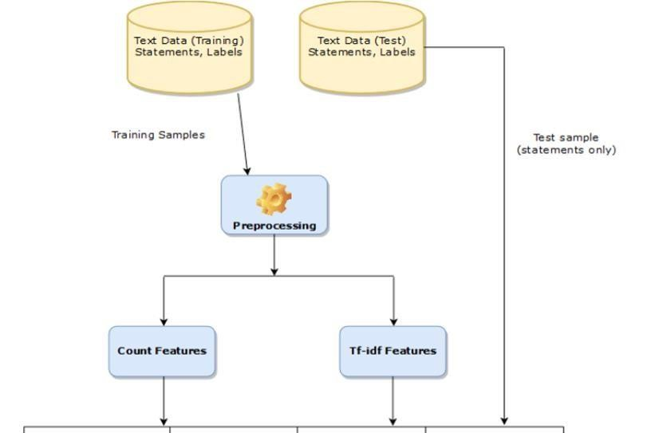

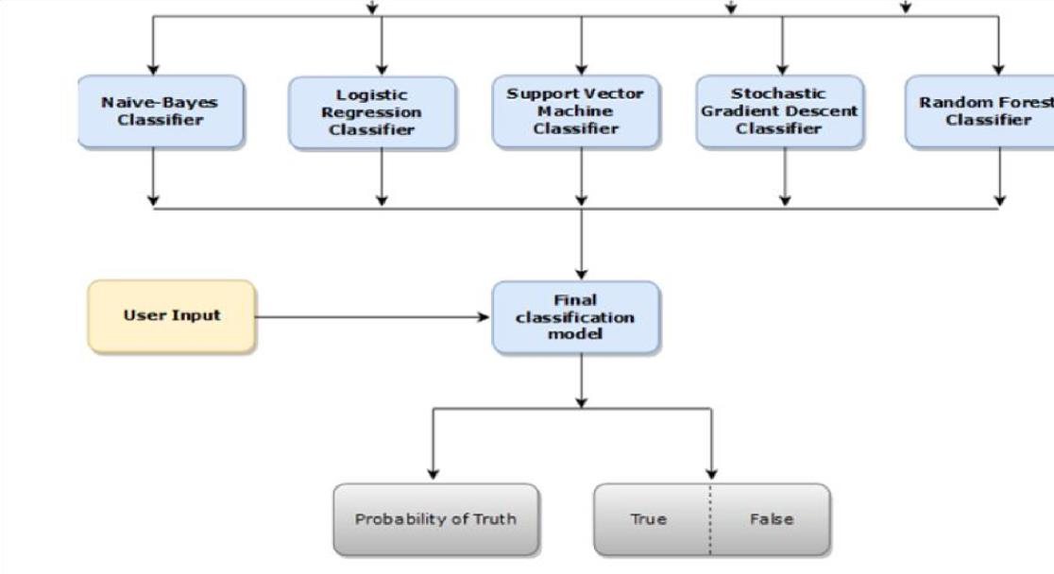

**Fig 3.1 Block Diagram of fake news detection system**

Additionally, some systems may incorporate natural language processing techniques to analyze sentiment, coherence, and contextual information within the text. This helps in understanding the underlying intent and context of the news. Furthermore, some systems may leverage external sources like fact-checking databases or historical data to corroborate or refute the claims made in the news. The final output is a probability score or binary classification indicating the

likelihood of the news being fake. These systems play a crucial role in combating the spread of misinformation and ensuring a more informed and discerning public

We are going to use basic web development tools like HTML, CSS ,Javascript for the designing of user interface for the system

###### 3.3 Methodology

The methodology for a Fake News Detection System involves a systematic approach to develop, train, and evaluate a model capable of discerning between genuine and fabricated news articles. Below is a step-by-step methodology:

1. Data Collection and Preparation: Collect a Diverse Dataset: Gather a balanced dataset containing both genuine and fake news articles. Ensure diversity in topics, sources, and writing styles.
2. Data Cleaning: Preprocess the data to remove noise, including HTML tags, special characters, and irrelevant information. Handle missing values if necessary. 3. Feature Extraction:

Linguistic Features: Extract features like word frequencies, n-grams, and syntactic patterns to capture linguistic nuances.

Semantic Features: Utilize techniques like word embeddings (Word2Vec, GloVe) or contextual embeddings (BERT) to understand semantic relationships between words.

Contextual Cues: Integrate external information such as source credibility scores, social media engagement metrics, or URL metadata.

1. Labeling and Training Data: Annotate the dataset with appropriate labels (e.g., 'genuine' and

'fake').

1. Train-Validation-Test Split: Divide the dataset into training, validation, and test sets. The training set is used to train the model, the validation set helps in hyperparameter tuning, and the test set is kept separate for final evaluation.
2. Model Selection:

Logistic Regression:Used for binary classification tasks where the goal is to predict one of two possible classes. Despite its name, logistic regression is used for classification, not regression.

Decision Trees:Construct tree-like structures to make decisions based on input features. They can be used for both classification and regression tasks.

Random Forest:Ensemble learning method that combines multiple decision trees to improve accuracy and generalization. It's effective for both classification and regression.

1. Model Training: In our project, model training stands as a foundational step in crafting our fake news detection system. This pivotal process entails leveraging a dataset meticulously curated to educate the model in discerning patterns indicative of fake news, thereby empowering it to accurately identify misinformation, distinguish credible sources, and ultimately fulfill its role in mitigating the spread of deceptive content.

Train the Model: Use the training set to train the chosen algorithm. The model learns to differentiate between genuine and fake news based on the features extracted.

Hyperparameter Tuning: Optimize hyperparameters (e.g., tree depth, learning rate, regularization) using the validation set to prevent overfitting.

8.Iterative Process and Fine-tuning: Based on evaluation results, fine-tune the model, adjust features, consider different algorithms. This step may involve reiterating through steps 4 to 6.

9.Model Deployment and Integration: Prepare the model for deployment in a real-world setting.

Ethical Considerations: Consider ethical implications, such as potential biases in the data or decisions made by the model. Mitigate biases where possible.

##### 4. Implementation Detail

###### 4.1 Experimental Setup

Our experimental setup for the fake news detection system involved utilizing Flask to create the user interface. We employed machine learning techniques to classify the authenticity of the dataset. Notably, our system operates on static datasets, providing reliable results for the classification of news articles.

4.1.1 Dataset Description/Database Details

We have used two datasets for the proposed system consisting of fake news and true news this dataset is being downloaded from kaggle. Below fig 4.1 is of the excelsheet representing dataset which we have used for machine learning purposes



fig 4.1 dataset for fake news detection system

###### 4.2 Performance evaluation

We have tested the dataset on various algorithms. Here is the graphical analysis of data based upon different algorithms. Below is the Diagramatic representation of results obtained using different algorithms. The diagram shows the confusion matrix obtained by aopplying different algorithms.

A confusion matrix is a fundamental tool in the field of machine learning and classification tasks. It provides a detailed summary of the performance of a classification model by presenting a grid that illustrates the predicted and actual classes of a set of data. The matrix consists of four main components: true positives (TP), true negatives (TN), false positives (FP), and false negatives (FN). True positives represent the instances where the model correctly predicted the positive class, while true negatives denote instances where the model correctly predicted the negative class. On the other hand, false positives occur when the model incorrectly predicts a positive class, and false negatives occur when the model incorrectly predicts a negative class. These metrics are crucial for evaluating the performance of a model, as they allow for the calculation of various performance metrics like accuracy, precision, recall, and F1-score. The confusion matrix serves as a valuable diagnostic tool, providing insights into the strengths and weaknesses of a classification model and helping practitioners make informed decisions about its effectiveness and potential areas for improvement.

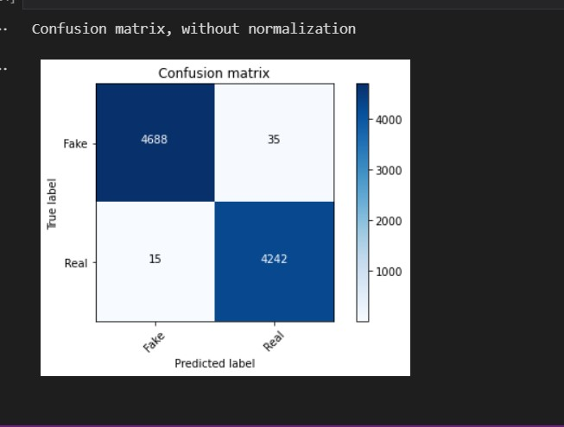

Fig 4.2.1 SVM Confusion matrix

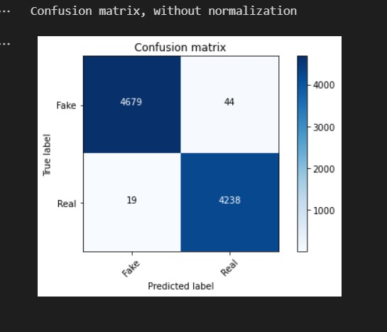

Fig 4.2.2 Random forest Confusion matrix

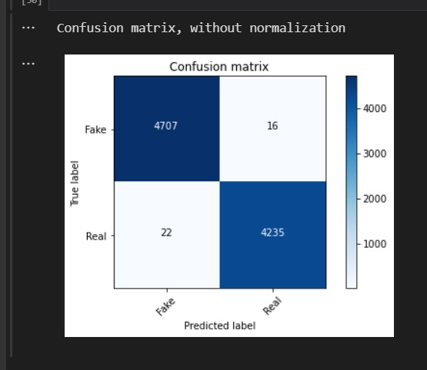

Fig 4.2.3 Decision Tree confusion matrix

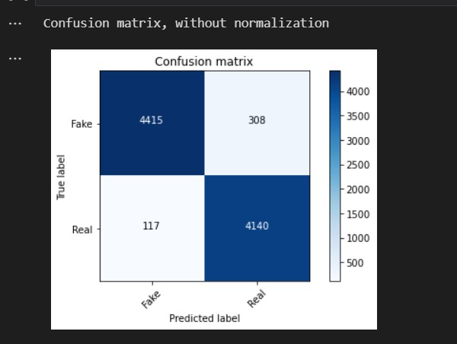

Fig 4.2.4 Confusion matrix for Logistic regression



fig 4.2.5 Accuracy from different algorithms

1. Naive Bayes achieved an accuracy of 95% in the classification task.
2. Logistic regression demonstrated an accuracy of 98% in predicting outcomes.
3. Decision tree modeling yielded an impressive accuracy of 99.5% in classification.
4. Random forest algorithm showcased a high accuracy rate of 99.3% in prediction tasks.
5. Support Vector Machine (SVM) achieved an accuracy of 99% in its classification performance.

**Comparison Table for Different Algorithms**

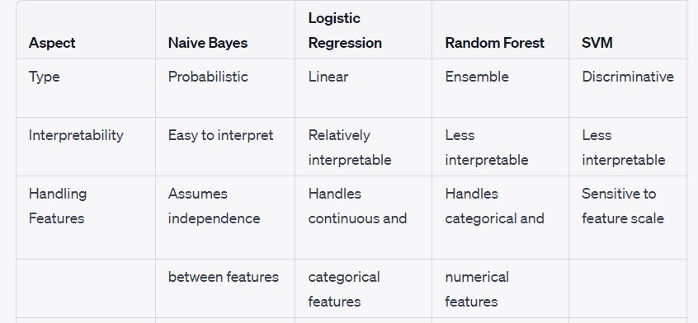

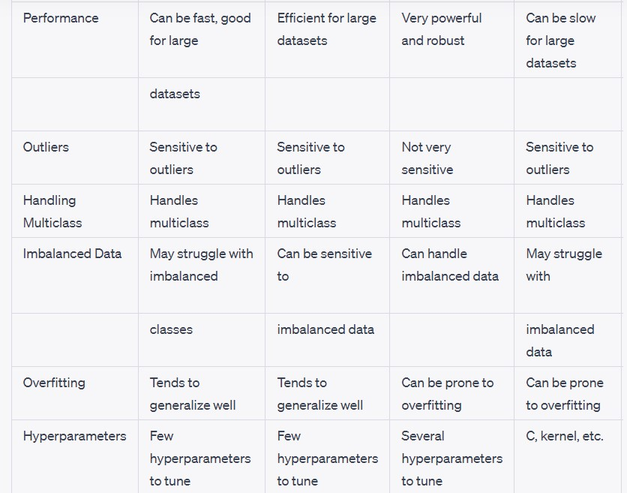

**Conclusion of the table:**

The table provides insights into the performance of various algorithms on the dataset, specifically focusing on their accuracy in classifying news articles as either fake or true. It offers a comparative analysis, shedding light on the effectiveness of each algorithm in handling the classification task.

**4.3 UI for the System**



4.3.1 UI Home page



4.3.2 Fake news



4.3.3 True news

###### 4.4 Software and hardware setup

1. The operating system of the HP laptop is Windows 11, which operates on a 64-bit architecture. The laptop features an Intel Core i5 processor from the 10th generation.
2. The project employs several libraries, including Pandas, NumPy, and scikit-learn. These libraries are utilized for various tasks such as data manipulation, numerical computing, and machine learning algorithms

###### 5. Conclusion

In summary, fake news detection systems employ algorithms and linguistic analysis to discern the authenticity of news content. They serve as crucial tools in combating misinformation, enabling a more informed public. Continued development in this field is essential for upholding the integrity of information dissemination

### 6. References

[1]https://www.simplilearn.com/tutorials/machine-learning-tutorial/how-to-create-a-fake-newsdetection-system

[2]https://paperswithcode.com/task/fake-news-detection

[3]https://www.projectpro.io/article/fake-news-detection-project/854

[4]https://www.projectpro.io/article/fake-news-detection-project/854

[5]https://iopscience.iop.org/article/10.1088/1757-899X/1099/1/012040/pdf

[6]https://www.javatpoint.com/fake-news-detection-using-machine-learning

[7]https://www.hindawi.com/journals/complexity/2020/8885861/

[8] https://ieeexplore.ieee.org/document/9378748